# QUESTION PAPER -3

**QUANT QUESTIONS**

1. What is the 28383rd term in the series 1234567891011121314............
   1. 3
   2. 4
   3. 7
   4. 9

1. Two number are in the ratio 3 : 5. If 9 is subtracted from each, the new numbers are in the ratio 12 : 23. The smaller number is:

1. 27
2. 33
3. 49
4. 55
5. Jackson travels 13 km up the stream in 5 hrs and also 28 km down the stream in 5 hrs. Find the velocity of the stream.
6. 1.5 kmph
7. 2.5 kmph
8. 1.2 kmph
9. 1.8 kmph
10. A is as much younger than B as he is older than C. If the sum of the ages of B and C is 40 years, what is definitely the difference between B and C’s age?

(a)5 years

(b)8 years

(c)Data sufficient

(d)None of these

1. At what time will the train reach city X from city Y?
2. The train crosses another train of equal length of 200 m and running in opposite direction in 15 seconds
3. The train leaves city Y at 7:15am for city X situated at a distance of 558 km
4. The 200 m long train crosses a signal pole in 10 seconds
   1. I only
   2. II only
   3. III only
   4. I or III only
   5. All I, II and III are required
5. The price of a sedan is $5,000. It was insured to 85% of its price. The car was damaged completely in an accident and the insurance company paid 90% of the insurance. What was the difference between the price of the car and the amount received?
6. $5000
7. $3000
8. $1175
9. $2350
10. A person lent out a certain sum on simple interest and the same sum on compound interest at a certain rate of interest per annum . He noticed that ratio between the difference of compound interest and simple interest of 3 years and 2 years is 28 : 9. The rate of interest per annum is :
$9\frac{1}{11}\%$

$12\frac{1}{2}\%$

$8\frac{3}{4}\%$

$10\frac{2}{3}\%$

11. Consider a courier company A which can deliver 100 parcels in 5 days with 5 men working for 8 hours a day. Consider another courier company B where every employee is equally efficient as that of company B. Company B is short of one man when compared to A and has a policy of asking its workers to work only for 6 hours a day. How long (in days) company B will take to deliver 100 parcels.
    1. 8.3
    2. 24
    3. 12
    4. 6.6
12. How many words of 4 consonants and 3 vowels can be made from 12 consonants and 4 vowels, if all the letters are different?
    1. 16C7 * 7!
    2. 12C4 * 4C3 * 7!
    3. 12C3 * 4C4
    4. 12C4 * 4C3
13. Four geometric means are inserted between 1/8 and 128. Find the third geometric mean.
    1. 4
    2. 16
    3. 32
    4. 8
14. Rama covers a distance of 40 km in the direction of current and 28 km against the current. If in each case he takes 4 hours, then find the speed of the current.
15. 2 km/hr.
16. 1.5 km/hr.
17. 2.5 km/hr.
18. 1 km/hr.

**LOGICAL**

**Directions : Each question contains six statements followed by four sets of combinations of three. Choose the set in which statements are logically related**

1. 1. A thesis is considered exceptional for it's originality
   2. Some thesis are original
   3. All thesis are not exceptional
   4. Sameera's thesis is exceptional
   5. All thesis are not considered original
   6. Sameera's thesis is original
2. FBE
3. ACD.
4. DBC.
5. ADF

Choose the correct answer that logically follow the main statement.

1. I will not have enemies unless I fight.
   * + 1. I have enemies implies I will fight.
       2. I do not fight implies I will not have enemies.
       3. I fight implies I will have enemies.
       4. both a) and b).

**ANALOGY**

1. Blizzard : storm : : _________ : _________
   1. Novelist : writer
   2. Boat : submarine
   3. Radio : television
   4. Organization : party

**SERIES COMPLETION**

1. DEF def G ??
   1. HI gih
   2. IH ghi
   3. HI ghi
   4. HI ihg

**DATA SUFFICIENCY**

1. Which direction is the bird flying in?
2. If the bird turns right and turns right again, then it’ll be facing north.
3. If the bird flies a little distance, turns right and flies a little more, then its beak will be pointed towards the right of a river that is flowing south.

|  |
| --- |
| 1. I alone is sufficient while II alone is not sufficient. |
| 1. II alone is sufficient while I alone is not sufficient. |
| 1. Either I or II is sufficient. |
| 1. Neither I nor II is sufficient. |
| 1. Both I and II are sufficient. |

**VERBAL**

1. Give the synonym of the below given word
   1. SODDEN

|  |  |  |  |
| --- | --- | --- | --- |
| [A.](javascript:%20void%200;) | dry | [B.](javascript:%20void%200;) | Sad |
| [C.](javascript:%20void%200;) | soaked | [D.](javascript:%20void%200;) | fall |

PARAJUMBLE:

1. Arrange the sentences in proper sequence
2. The evils of sound pollution can be imagined from this example.
3. There are two villages near Dum Dum airport in Calcutta where a large number of people have lost their power of hearing.
4. The harsh sounds of buses, its, mopeds etc. affect our power of hearing.
5. This is because of the frequent sounds of planes coming in and going out of Dum Dum Airport.
   * 1. 3241
     2. 2314
     3. 1324
     4. 3412

SENTENCE COMPLETION

1. Very often humans have raised wild, producing ______individuals with softer

appearances and more _____ temperaments, such as guinea pigs and dogs*.*

1. Determined…meek
2. Obstinate…fierce
3. Tame…. **docile**
4. Headstrong…prosaic
5. Pliable…valiant

In the following questions choose the word which is the exact OPPOSITE of the given words.

1. DREADFUL
2. Pleasant
3. Atrocious
4. Awful
5. Beastly
6. MITIGATE
7. Abate
8. Intensify
9. Calm
10. Compose

**DATA INTERPRETATION**

**Study the following Bar Diagram and answer Q22-Q25**

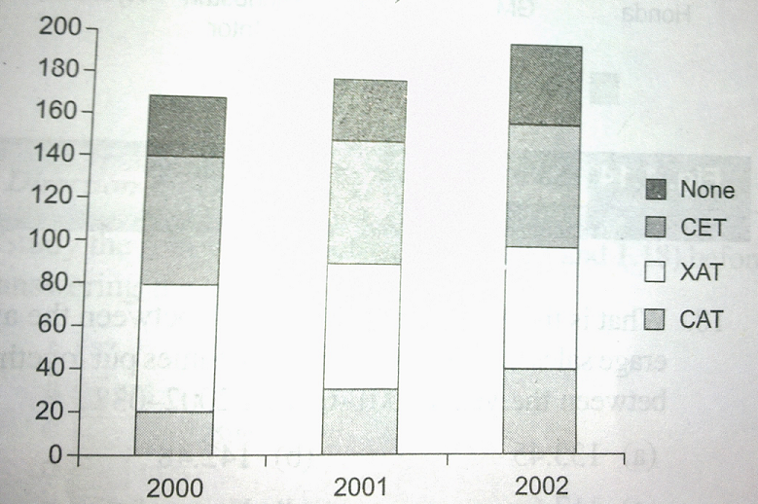  
  
**The above chart represents the number of students of XYZ careers at its Lucknow centre who passed the CAT exam or XAT exam or the CET exam or none of the exams. (Assume that there are no students who passed more than one exam.)**

1. **What was the percentage of students who cleared CAT in 2000?**

A. 19.56% B. 12.65% C. 14.28% D. 11.76%

1. **What was the percentage of students who succeeded in at least one of the three exams in 2000?**

A. 82.4% B. 82.8% C. 82.35% D. 83.3%

1. **Which year showed the best result in MBA entrance exams for the institute (in terms of %age)(Note all the three are MBA entrances.)**

A. 2000 B. 2001 C. 2002 D. Cannot be determined.

1. **What is the percentage increase on the number of students in 2002 over 2000?**

A. 30% B. 17.64% C. 117.6% D. 85%

1. **The following pie chart shows the amount of subscriptions generated for the India Bonds from different categories of investors.  
     
   What should be the degree of the region represented by ‘Corporate Houses’?**A. 122.4 B. 122.8 C. 121.8 D. 122.0
2. **If the investments by NRIs are Rs 4000 crore, then the investment by corporate houses and FIIs together is:**A. 24000 crore B. 24,363 crore C. 25,423.4 crore D. 25,643.3 crore

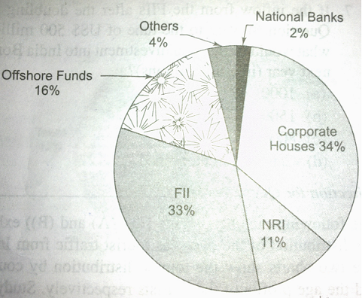

1. **What is the approximate ratio of investments made by NRIs to that of corporate houses?**A. 1:4 B. 1:3 C. 3:1 D. None of these
2. **If the total investment other than FII and corporate houses is Rs 335,000 crore, then the investment by NRIs and Offshore funds will be (approximately):**A. 274,000 B. 285,000 C. 293,000 D. Cannot be determined.

**READING COMPREHENSION**

India is yet again on the cusp of a battle for deeper democratization. The data from nationwide surveys have repeatedly shown that Indians increasingly view their elected representatives and political parties as uncaring, unreachable, unresponsive, untrustworthy, and unrepresentative. This overarching anger against the functioning of legislative institutions (particularly Parliament), political parties, and elected representatives has led to massive protests by citizens and civil society activists in the last few years. The office of the Chief Information Commissioner (CIC) and courts took cognizance of the matter and delivered a series of verdicts to deal with legislators with criminal records, free flow of black money during elections, needless competition among political parties to announce freebies, caste-based rallies, and massive corruption implicating many legislators. Similarly, the emergence of the AamAadmi Party (AAP) — a non-party political movement — is likely to force mainstream parties not to be brazen about the “win ability factor” in allocating ticket to candidates with criminal records and family ties.

Several commentators in the past few months have criticized the overzealous attempts by courts to clean up India’s party politics, and expressed doubts about whether the AAP will survive long enough in its idealistic mode to have any influence on the rules of conducting politics in India. We disagree with this view. Our concern in this article is not whether the AAP will succeed in the electoral battlefield or if these rulings delivered by the CIC and courts are an exercise in judicial overreach. We believe that citizens’ protests in the last few years signal a widespread consensus among all segments of society that the “rules of the game” of conducting politics in India need to change. We argue that even if political experiments (like the AAP) fail, they help substantially in moving the established norms to a new equilibrium. In our view, laws and rulings alone do not challenge established norms. However, the presence of a political party, mobilizing voters on a similar platform, helps in doing so by significantly strengthening the legal process itself, by disarming those who would seek to scuttle such change.

Legal decisions can never be permanent solutions for they are turned and overturned on the basis of interpretations of specific words/clauses of a statute or provision. Political parties and their leaders in India have few incentives to play by the rules. For instance, they are required to submit documents to the Election Commission (EC) about expenditures and contributions they receive. Many parties submit incomplete documents and others submit even more unbelievable documents. The BSP, for example, submitted a two-page affidavit to the Election Commission claiming that it had not received any donations above Rs. 20,000 — the legal limit above which all contributions need to be disclosed.

To clean up the muddy waters, courts and the EC have stepped in from time to time. BSP leader Mayawati’s rupee garland was considered a campaign contribution by the EC and needed to be declared. However, such interventions and judgments have often fallen short of expectations and have been indicative of judicial overreach.

30. The attitude of the author towards the ideologies of the AAP is that:

* 1. The influence of AAP’s struggle will befall upon the general mindset of the people regardless of the parties’ success.
  2. The AAP is overzealous about its ideologies and may be unsuccessful in influencing the legislature in the long run.
  3. The AAP ideologies will appeal to the public but will be ineffective in affecting the political scenario.
  4. presence of AAP is a hindrance to the established norms of the law making bodies.
  5. AAP prevents the changes occurring in the legal process.

1. What does the author feel about the interpretation of the legal decisions?
   1. The laws are interpreted and altered by parties so as to suit their immediate requirements.
   2. Interpretation of the laws has to be uniform and discreet.
   3. Laws are flexible to suit the needs of the parties.
   4. Parties seldom obey the rules while campaigning for elections.
   5. Disclosure of documents to the electoral commission is inaccurate.
2. What does the author assume about the state of documents that the political parties submit to electoral commission?
   1. The documents are manipulated and falsified showing inaccurate representations of their revenue.
   2. The documents submitted by the parties include the expenditures and contributions they receive and are accurately depicted.
   3. The electoral commission is aware of the state of expenditures and gains of each party.
   4. The documents are accurate but to a certain extent.
   5. The electoral commission ignores ambiguities in the documents and sails along with the interests of the parties.
3. What does the author feel about the effectiveness of the electoral commission in curbing the ambiguities in the actual revenue of parties and that which is declared?
   1. Electoral commission works towards identifying each misinformation and prosecutes the defaulting party.
   2. The electoral commission is powerless in controlling the large number of falsified claims that it encounters.
   3. EC has been effective in reducing the ambiguities drastically due to its strict policies.
   4. EC has been influenced by the greater power of ruling parties.
   5. EC has yet to come up with strategies to avoid ambiguities
4. The ratio between the length and the breadth of a rectangular playground is 3: 2. If a man cycling along the boundary of the playground at the speed of 12 km/hr. completes one round in 8 minutes, then what is the area of the playground (in sq. m)?
5. 153480
6. 153320
7. 153600
8. 153500
9. Log4 x + log2 x =6 Find x.

A) 8 B) 16 C) 24 D) 28

36. Six persons namely Ranjith, Daniel, Virat, Amit, Vinay and Praveen are standing in a queue to get a train ticket in a railway station. Ranjith is standing between Vinay and Pradeep. Pradeep is ahead of Daniel and Vinay is standing behind Amit. Virat is standing behind Daniel. Due to closing time at the ticket counter, they will give tickets only to the first four persons. Who will not get the tickets?

A. Daniel and Vinay B. Pradeep and Vinay C. Daniel and Virat D. Pradeep and Virat

37. A car moves at the speed of 60km/hr. What is the speed of the car in metres per second?

a)50/3

b)60

c)50/9

d)None of these

38. Anupam said to a lady sitting in a car, "The only daughter of the brother of my wife is the sister-in-law of the brother of your sister." How the husband of the lady is related to Anupam?

A. Maternal uncle B. Uncle

C. Father D. Son-in-law

39. In a 200m race, if X gives Z a start of 25 metres, then X wins the race by 10 seconds. Alternatively, if X gives Z a start of 45 metres the race ends in a dead heat. How long does X take to run 200m? 

1. 100 seconds
2. 112.5 seconds
3. 77.5 seconds
4. 87.5 seconds

40. The sum of third and ninth term of an A.P is 8. Find the sum of the first 11 terms of the progression.  
  
a) 44  
b) 22  
c) 19  
d) None of these